SUMMERVILLE CREDIT UNION · CONSOLIDATED MEMBER GUIDE
View Card Details

Module: nFinia Digital Banking > Cards > Card Details
01 PRODUCT SUMMARY

The Card Details page provides a full view of an individual card including the masked card number, expiry, CVV reveal option, membership number, card status, available credit, current balance, and reward points (for eligible cards). From this page you can directly access all card management actions: Card Controls (Spending Limits, Usage Control, Card Alerts, Location Controls), Set PIN, Deactivate / Replace Card, and View Account.
Card Details is the gateway to all card-specific settings. Any time you need to manage a specific card — whether adjusting controls, checking balances, updating your PIN, or reporting it lost — Card Details is where you begin.

At a Glance
Attribute | Detail
Module | nFinia Digital Banking > Cards > Card Details
Access | Cards list > click on a card
Information Shown | Card image, masked number, expiry, CVV (reveal option), membership, status, balance
Reward Points | Shown for eligible credit cards (available, expiring, total due, payment due date)
Actions Available | Card Controls, Set PIN, Deactivate / Replace Card, View account

02 KEY USE CASES

Use Case | Who Uses It | What They Do | Business Value
Check card balance | Member wanting to view current balance and available credit | Opens Card Details for the relevant card | Up-to-date balance and credit limit without calling the CU
Reveal card number or CVV | Member who needs card details for an online purchase | Clicks Reveal card number and CVV on the Card Details page | Masked details revealed securely within the banking session
Access card controls | Member wanting to manage spending limits or location controls | Opens Card Details then clicks Card Controls | All card control sub-features accessible in one place
View reward points | Member checking credit card rewards | Opens Card Details for their credit card | Points balance, expiring points, and total due displayed on the tile

03 STEP-BY-STEP GUIDE

Navigation: Log in to Summerville Credit Union online banking. Click Cards in the top navigation bar, then click on the card you want to view.
Step 1 — Arrive at the Dashboard
After logging in, you land on the Dashboard showing your account balances, recent payments, and quick-action shortcuts. Click Cards in the top navigation bar to open your card list.
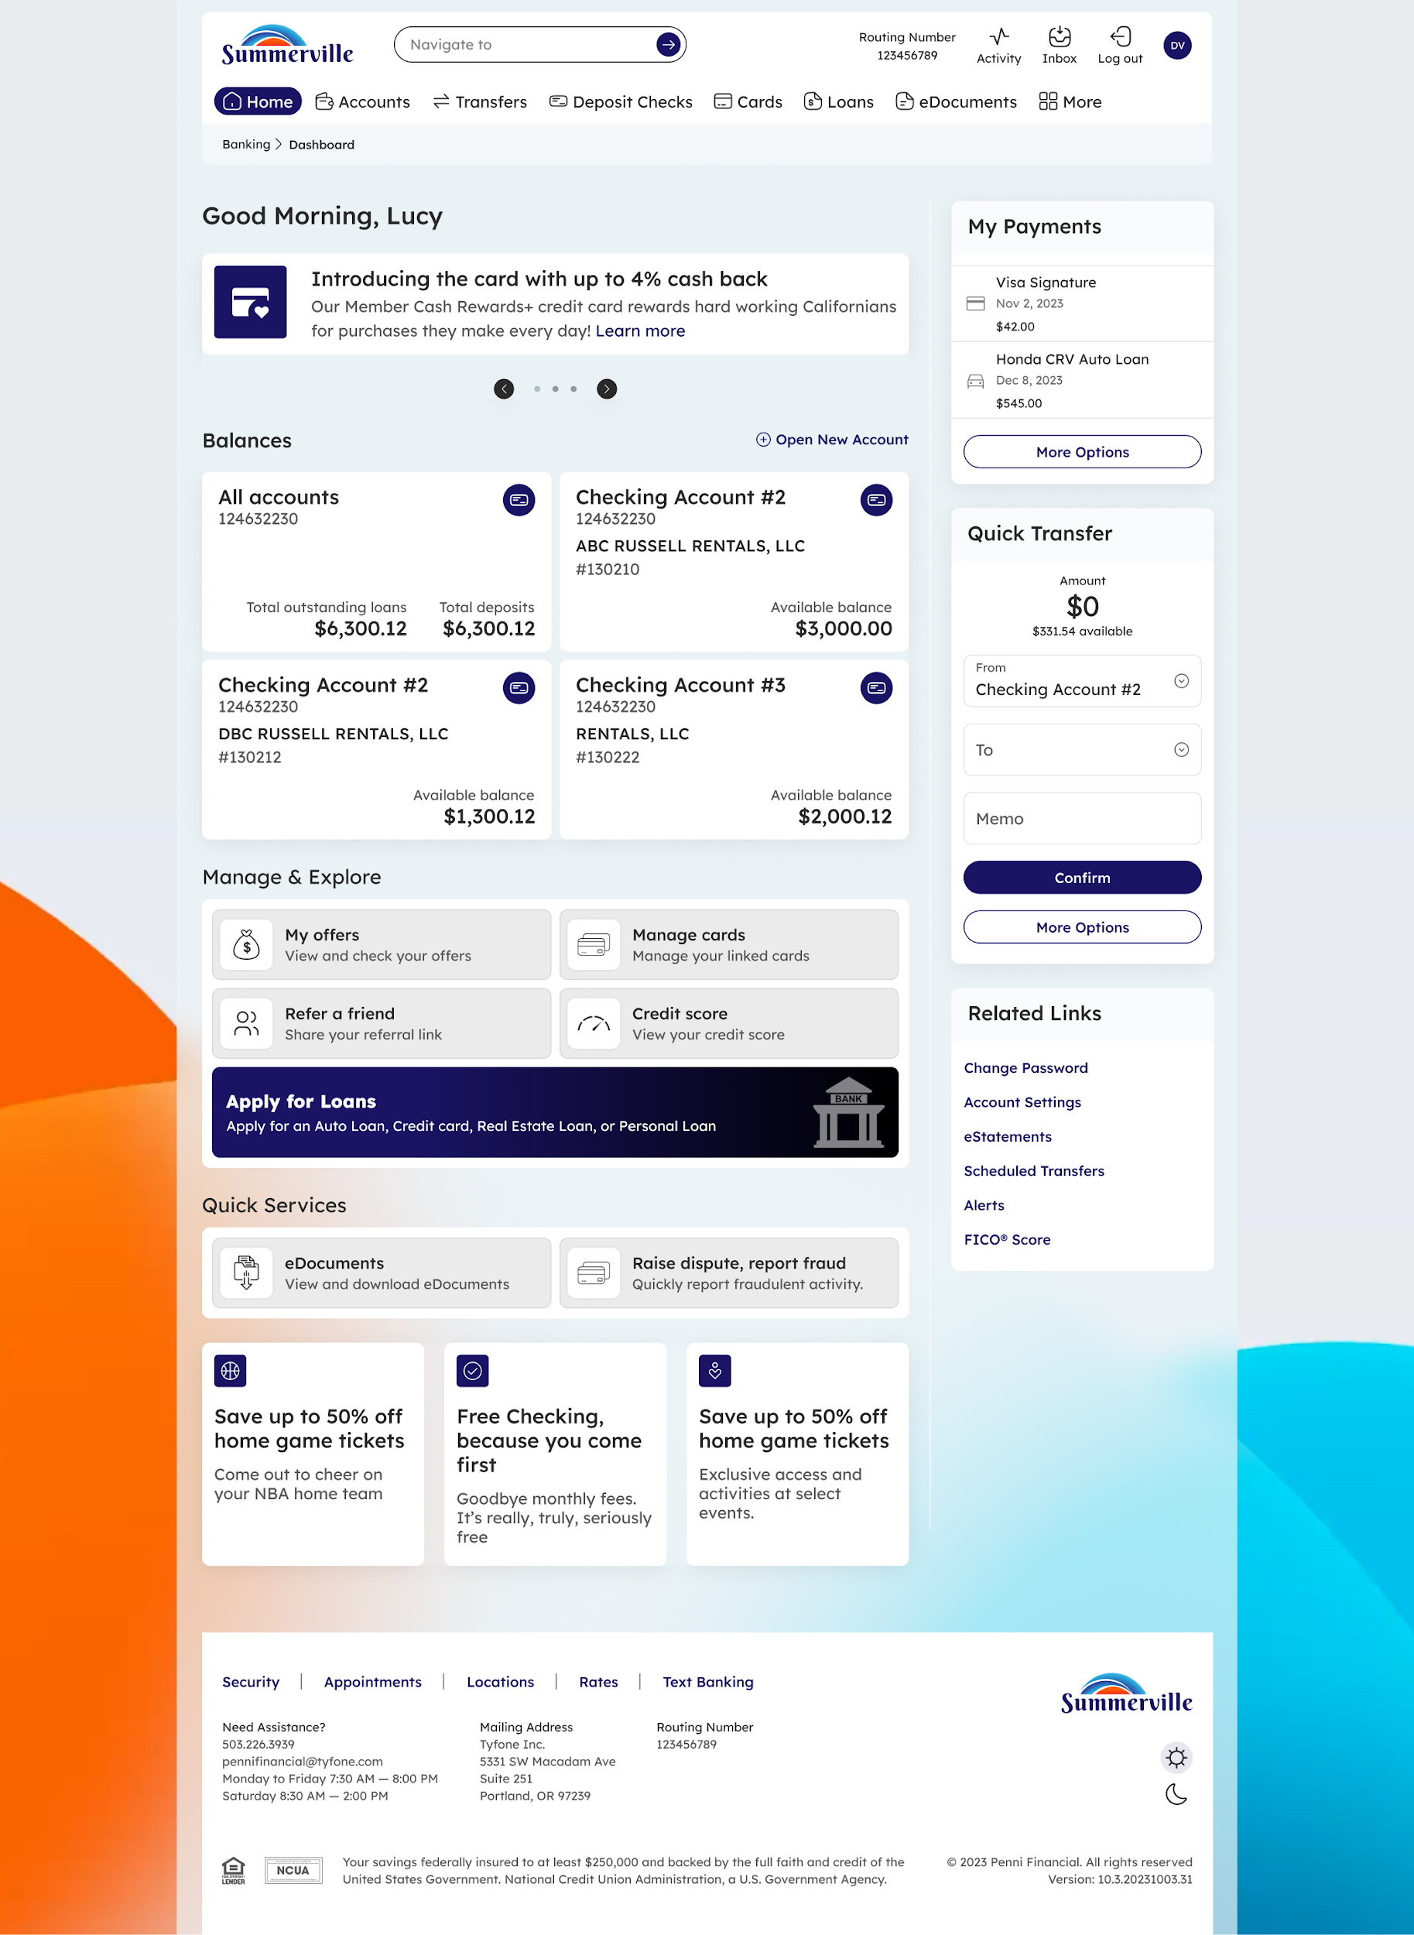
Step 1: Dashboard — starting point for navigation
Step 2 — Select a Card to View Details
On the Cards page, each card tile shows a summary view. Click on the card tile or use the Card Controls / Set PIN / Deactivate links at the bottom of the tile to navigate into that card's detail view. The Card Details page loads, showing the full card image, account information, status toggle, balance summary, and quick action links along the top of the detail panel.

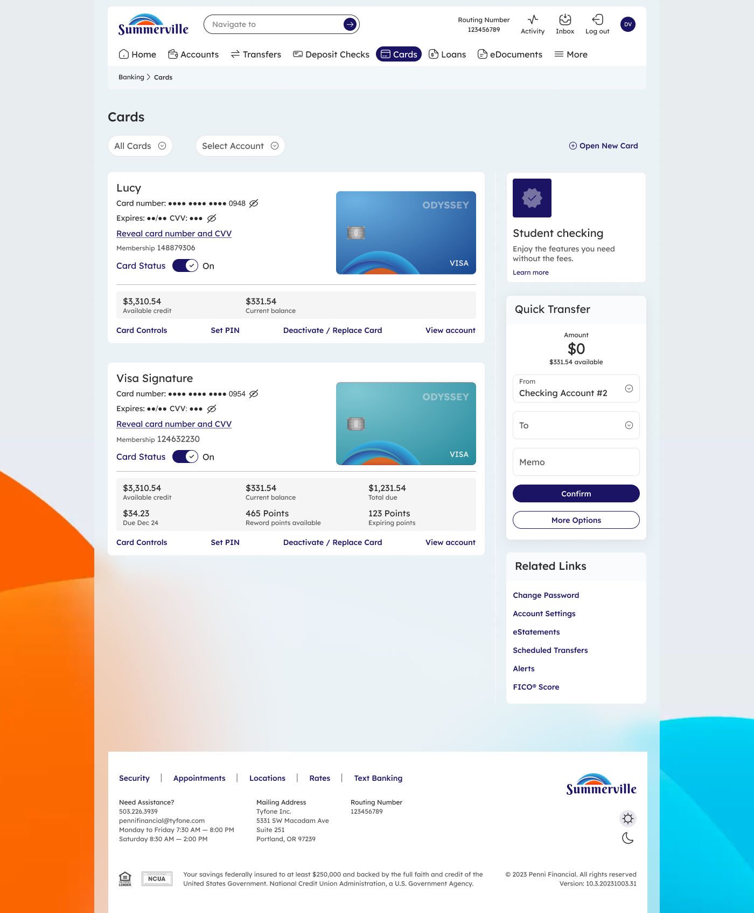
Step 2: Cards list — click any card or its action links to open Card Details
Note: If your card has reward points, the Card Details view shows Available Reward Points, Expiring Points, and your payment due date. Use the View account link to see full transaction history for that card.

